Swami Rama Himalayan University Secured NAAC A+ Accreditation in its 1st Cycle

Swami Rama Himalayan University (SRHU) has been awarded **A+** by the prestigious National Assessment and Accreditation Council (**NAAC**), which places it among the 6% of higher education institutions (HEIs) in India to be granted such a coveted grade. The University scored a Cumulative Grade Point Average (CGPA) of 3.27 on a 4-point scale.

The Peer Team visit was completed between 7-9 October, 2024. The detailed score along with grade card was issued by NAAC on 18th October after 221st Standing Committee/Executive Committee of NAAC. Swami Rama Himalayan University has been accredited with A+ grade valid for five years upto October, 2029.

The University has been praised for three major features by the Peer Team. They are very good infrastructure & learning resources, curriculum development, Institutional Values and Best Practices, a neat and clean, green, and well-maintained campus.

Congratulating the SRHU fraternity on the achievement, Dr. Vijay Dhasmana, President, SRHU asserted that this is a testimony to the institutions arduous work, focus and dedication towards quality education. He said that the University will continue to achieve excellence in teaching, research and innovation while also taking on responsibility for the counseling and care of the students as a guardian. He also mentioned that we have to further promote multidisciplinary education and research involving young talents available in the academic units/departments for getting international accreditations in future.

Dr. Rajendra Dobhal, Vice Chancellor of the University, congratulated all the SRHU stakeholders for getting NAAC A+ Grade in first cycle and made NAAC reports public. He mentioned that SRHU is the first Private University in Uttarakhand and Utter Pradesh who received A+ ranking under Medical Science Category after King George's Medical University, Lucknow being a Government University. He mentioned that various dynamic collaborations of international repute have been established for projects, conferences and cultural immersion across the campus.

Director General-Academic Development Dr. Vijendra Chauhan expressed his sincere thanks to all stakeholders who worked beyond their limits. He recognized many faculty members and staff who contributed at lot for the finalization of NAAC-SSR. By studying in an institution that is NAAC accredited, students get a chance to learn in a cutting-edge environment and earn a degree that will have global recognition. They get instant recognition as an alumnus of a credible institute and get better placement opportunities as the industry prefers hiring with higher-graded institutions.

Director IQAC Dr. Pradeep K. Varshney mentioned that with the blessings of Swami Ji and support of all stakeholders, SRHU is able to achieve another milestone of NAAC A+ grade. He expressed his sincere thanks to all members of BOG, members of BOM, members of Academic Council, all members of SRHU family including all Endowment Chairs, Emeritus Professors, Professor-of-Practice, Distinguished Visiting Faculty Members, Advisors, Directors, Principals, Vice Principals, HoDs, GM and DGMs, faculty members, staff members, and other supporting staff. He also mentioned that we will continue with same zeal to achieve other milestones of international ranking QS-I-Gauge and others. The NAAC accreditation will create new avenues for the university faculty members and its students”.

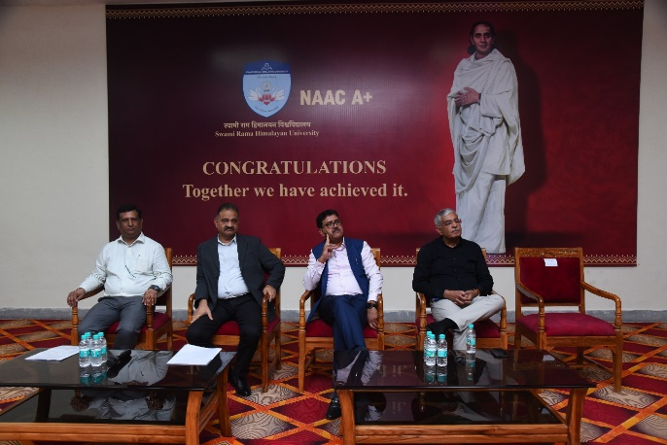

SRHU Celebrating NAAC A+ Grade by organizing “Thanks & Appreciation” in Dhanvantri Auditorium on 23.10.2024

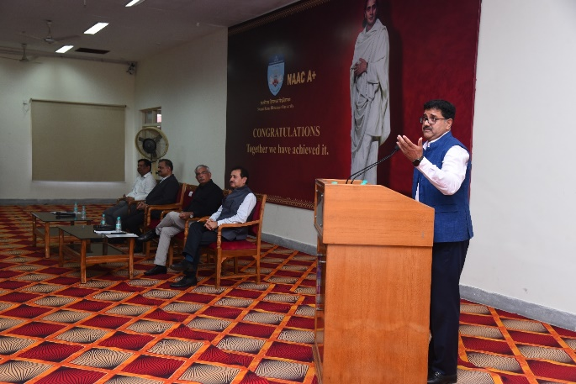 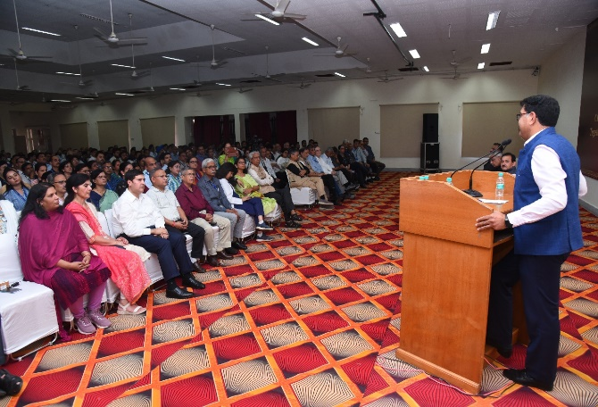

President, SRHU Dr. Vijay Dhasmana addressing to Faculty, Staff and Students to continue to achieve excellence in teaching, research and innovation

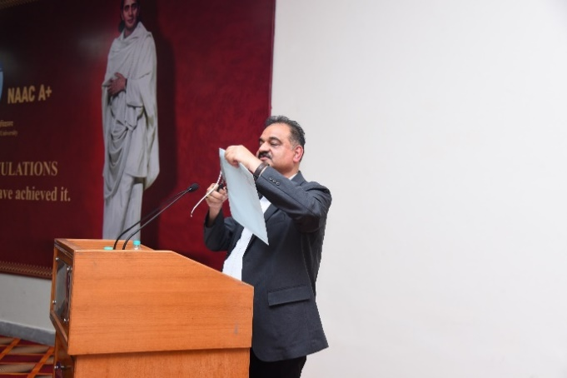 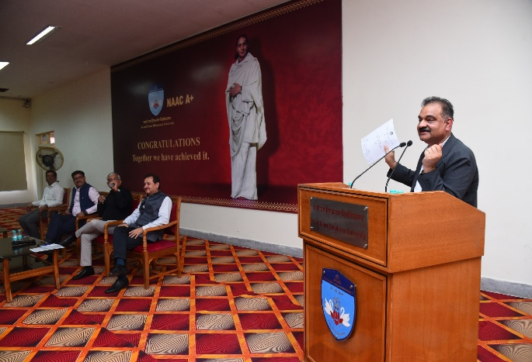

Vice Chancellor, SRHU Dr. Rajendra Dobhal, FNASc congratulating all Stakeholders for getting 1st Private University in UP & Uttarakhand under Medical Science Category

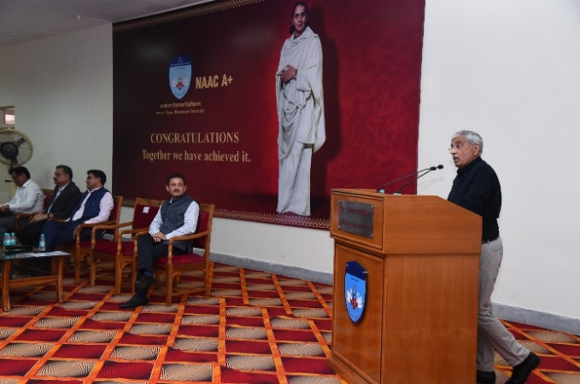 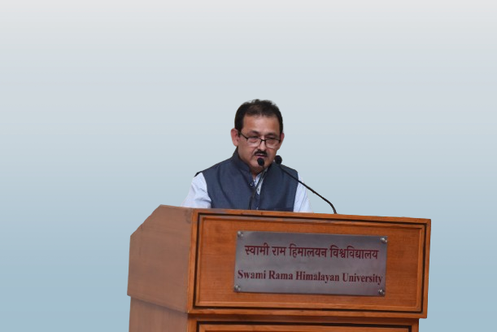

Director IQAC Dr. Pradeep K. Varshney expressing his sincere thanks to all BOG, BOM, AC member, IQAC Team and other stakeholders

Director General-AD Dr. Vijendra Chauhan expressed his sincere thanks to all stakeholders who worked beyond their limits

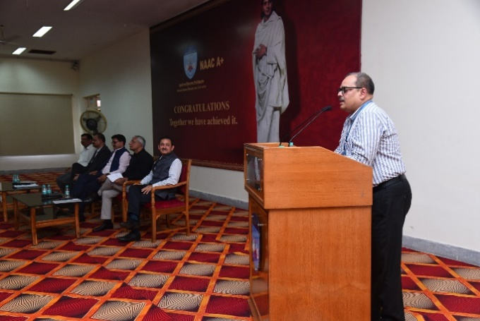

Criterion Leader-3 Dr. Sanjay Gupta expressing his view on NAAC A+ achievements

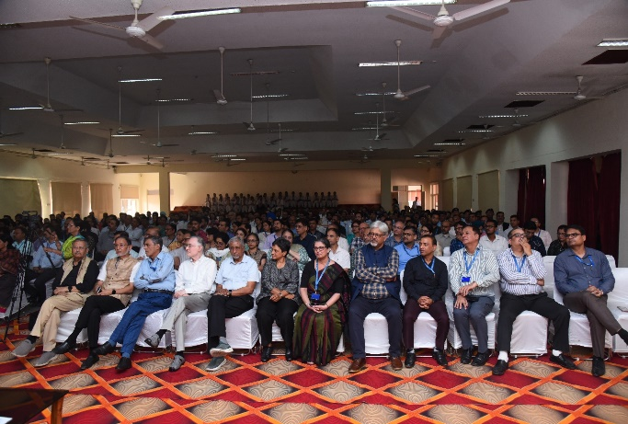 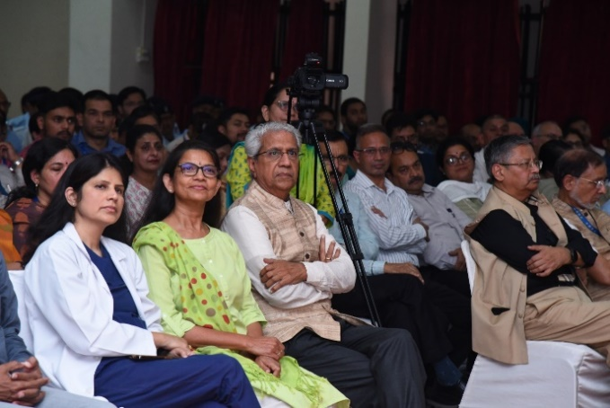

Principals of various Academic Units and Officers of the University